REAL TIME EMOTION DETECTION

WITH MANWATCHING

A Project Report

Submitted By:

Sristita Paul, University Roll: 15500121020

Roshni Chaubey, University Roll: 15500122087

Under the guidance of

**Prof. Kaustav Sanyal**

For the partial fulfillment of **Bachelors of Technology**

In **Computer Science & Engineering**

Under **Maulana Abul Kalam Azad University of Technology**



Submitted To:

**Durgapur Institute of Advanced Technology & Management**

Approved by AICTE, New Delhi and Affiliated to MAKAUT, West Bengal

**Acknowledgement**

I would like to take this opportunity to express my gratitude to all individuals associated with this project.

I am thankful to **Durgapur Institute of Advanced Technology & Management** to learn and upskill here. I am glad to express my profound thanks for the priceless and valuable advice and guidance delivered to me by our guide **Prof. Kaustav Sanyal**, HOD (In-Charge), Department of Computer Sciences & Engineering.

I am thankful to our principal, all faculty members of Computer Science & Engineering, data collectors and respondents of the questionnaire and all those who have helped me a lot in pursuing this project work in the department as without their support, I could not get into the realities. Thanking You.



15500122087

15500121020

**Table of Contents**

**ABSTRACT** 4

**INTRODUCTION** 5

**OBJECTIVE** 5

**HARDWARE & SOFTWARE REQUIREMENTS** 6

**BACKGROUND THEORY** 7

**LITERATURE SURVEY** 8

**METHODOLOGY** 10

**RESULT** 12

**DISCUSSION** 14

**CONCLUSION** 15

**References** 16

# **ABSTRACT**

The project “Real Time Emotion Detection with Manwatching” presents a real-time emotion detection system inspired by Desmond Morris's "Manwatching: A Field Guide to Human Behavior", which explores human non-verbal communication. Utilizing computer vision and machine learning, the system leverages OpenCV for image processing and a Convolutional Neural Network (CNN) for emotion recognition. The primary goal is to identify and display emotions such as Happy, Sad, Neutral, and Surprised from live video feeds and map those emotions to the characteristics of human emotions as described in the manwatching book. The system demonstrates the integration of behavioral science insights with advanced technology to enhance human-computer interactions in various applications.

*Keywords:* Behavioral Science, Computer Vision, Convolutional Neural Network, Emotion Detection, Human-Computer Interactions, Machine learning, Manwatching, Non-Verbal Communication, OpenCV;

# **INTRODUCTION**

Emotion detection plays a pivotal role in advancing human-computer interaction by enabling systems to understand and respond to human emotions. This project focuses on developing a real-time emotion detection system using computer vision and machine learning techniques with the main reference being “Manwatching: A Field Guide to Human Behavior”. By leveraging OpenCV for image processing and a Convolutional Neural Network (CNN) for emotion recognition, the system aims to accurately identify and display emotions such as Happy, Sad, Neutral, and Surprised from live video feeds and mapping those emotions to the manwatching characteristics related to human emotions.

# **OBJECTIVE**

The primary objective of the project "Real Time Emotion Detection with Manwatching" is to develop a real-time emotion detection system that utilizes computer vision and machine learning techniques to identify and display human emotions like angry, disgust, fear, happy, neutral, sad and surprise. Drawing inspiration from Desmond Morris's "Manwatching: A Field Guide to Human Behavior," the project aims to map these detected emotions to the characteristics outlined in the book.

# **HARDWARE & SOFTWARE REQUIREMENTS**

**Hardware Requirements:**

* Computer or embedded system capable of running image processing and machine learning algorithms.
* Webcam or camera for capturing live video feeds.
* Sufficient memory (Minimum 4 GB RAM) and processing power (1.6 GHz or faster processor) to handle real-time video processing.

**Software Requirements:**

* Python (Interpreter Version: 3.x)
* IDE (Integrated Development Environment) or Text Editor (Like Visual Studio Code etc.)
* Keras and TensorFlow (Latest Stable Versions)
* Other Python Libraries: pandas, numpy, tqdm, opencv-python, scikit-learn, jupyter, ipywidgets;

# **BACKGROUND THEORY**

In the contemporary landscape of computer vision and deep learning, real-time emotion detection from facial expressions stands as an intriguing application with numerous potential use cases. Following use cases are considered to clarify the significance of this project and why it has been made:

1. **Psychological Well-Being:** Emotions play a fundamental role in human behavior and interactions. Real-time emotion detection can provide valuable insights into an individual's psychological state, aiding in early detection and intervention for mental health issues such as depression and anxiety.
2. **Enhanced User Experience:** In human-computer interaction, understanding users' emotions in real-time can lead to more personalized and adaptive interfaces. By recognizing users' emotional states, systems can dynamically adjust content, layout, and interactions to optimize user experience and engagement.
3. **Security and Surveillance**: It can assist in identifying suspicious behavior or potential threats in public spaces, enhancing security measures and public safety.
4. **Retail and Marketing:** Emotion detection technology can revolutionize the retail industry by enabling retailers to fetch customers' emotional responses to products and advertisements in real-time. This information can be utilized to tailor marketing strategies, optimize product placements, and improve customer satisfaction.
5. **Education and Training:** Emotion detection can aid teachers and trainers in assessing students' engagement levels and emotional responses during lessons or training sessions.

# **LITERATURE SURVEY**

The primary goal is to detect a number of human emotions like angry, disgust, neutral, sad, happy, fear and surprise etc. with the mapping to real time characteristics with the help of Manwatching (Morris, 1977).

A real-time human emotion prediction model using a convolutional neural network (CNN) significantly reduces parameters and achieves 74% accuracy. (Jaiswal & Nandi, 2020)

Understanding human facial expressions is crucial for enhancing machine perception and broadening the applications of human-computer interaction. (Jaymon, Nagdeote, Yadav, & Rodrigues, 2021)

The project run the camera of your machine in order to recognize your face and detect the emotion. It’s pretty accurate. It creates a square around your face and put a text where there’s the emotion detected. (Pinto, 2022)

OpenCV's Haar feature-based cascade classifiers for object detection, focusing on face and eye detection. are provided using the cv::CascadeClassifier class in OpenCV to load pre-trained models and detect objects in video streams. (Cascade Classifier, n.d.)

A potential real-time approach for detecting human emotions involves extracting facial landmarks from detected faces and using various features and models for prediction. Experiments indicate the system achieves an average accuracy of approximately 74%. (Nguyen, Trinh, Phan, & Nguyen, 2017)

The rise of emotional intelligence in human-computer interaction underscores the importance of computers understanding human emotions, often gauged through facial expressions in video. However, the lack of authentic emotional data in existing databases poses a challenge for accurate automatic emotion detection systems. (Sun, Sebe, Lew, & Gevers, 2004)

An emotion detection system utilizing facial expressions from live feeds is implemented in Python using OpenCV and NumPy. By comparing testing data to a training dataset, the system accurately predicts human emotions, demonstrating its viability and effectiveness in computer vision research. (Puri, et al., 2020)

Convolutional Neural Networks (CNNs) are a type of deep learning neural network architecture specifically designed for processing grid-like data, such as images and videos. CNNs have revolutionized the field of computer vision and are widely used for various tasks, including image classification, object detection, facial recognition, and image generation. (Saw, 2023)

# **METHODOLOGY**

1. **Data Collection:** Dataset is downloaded from external source (OHEIX, 2019) and we have utilized that dataset to train the model ourselves.
2. The dataset contains facial expression images categorized into seven classes: anger, disgust, fear, happiness, sadness, surprise, and neutral.
3. The dataset is split into training and testing sets, with:

* Training set: 28,709 images
* Testing set: 7,178 images

1. Each image is grayscale and has a resolution of 48x48 pixels.
2. **Preprocessing:** 
   1. We first convert the input frame to grayscale because face detection is often performed on grayscale images for efficiency.
   2. We use the Haar Cascade classifier provided by OpenCV to detect faces in the grayscale frame. If a face is detected, we extract the region of interest corresponding to the face and resize it to a fixed size (e.g., 48x48 pixels) for consistency.
   3. We apply histogram equalization to enhance the contrast of the face region of interest, which can improve the performance of subsequent feature extraction.
   4. Then, we can normalize the pixel values of the face region of interest to the range [0, 1] for numerical stability.
   5. Finally, we return the preprocessed face region of interest for further processing, such as feature extraction and emotion recognition. If no face is detected in the frame, we return None.
3. **Model Training:** We are using a deep learning architecture for emotion recognition that is Convolutional Neural Networks (CNNs).
4. Split the dataset into training and validation sets.
5. Train the selected model using the training data. Fine-tune hyperparameters and architecture to optimize performance.
6. Validate the model using the validation set to ensure generalization.
7. **Emotion Recognition:**
8. Apply the trained model to predict emotions from the facial regions detected in real-time.
9. Integrate the emotion recognition module with the real-time video stream to visualize the predicted emotions.
10. **Integration with Manwatching:** Integrate the emotion recognition system with manwatching capabilities to enable simultaneous monitoring of individuals' behaviors and emotional states.
11. **Testing and Evaluation:** Test the real-time emotion detection system with various scenarios and conditions to assess its accuracy and performance.

# **RESULT**

Here are few snippets of the outputs generated by the application:

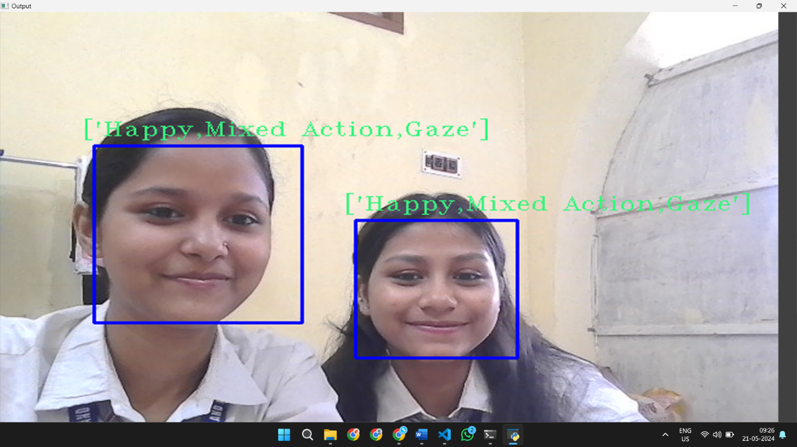

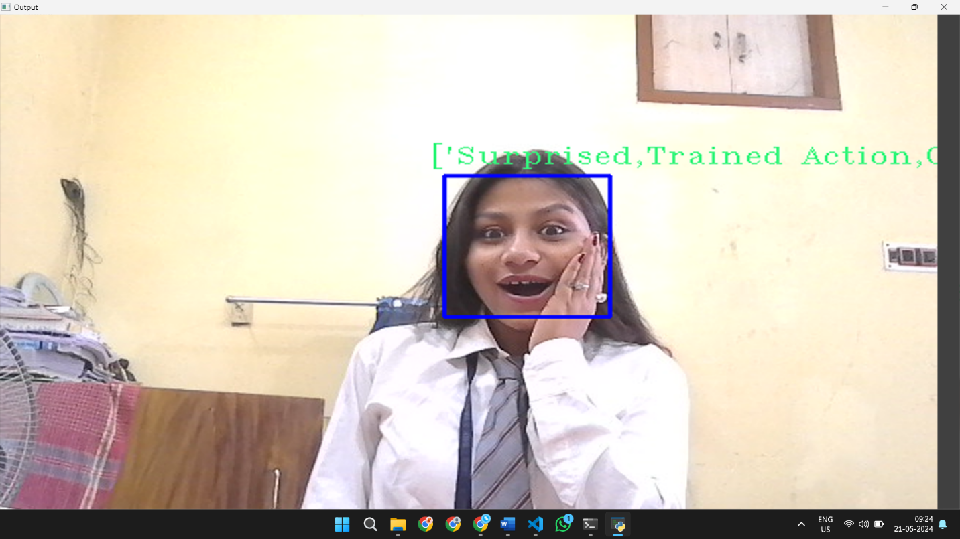

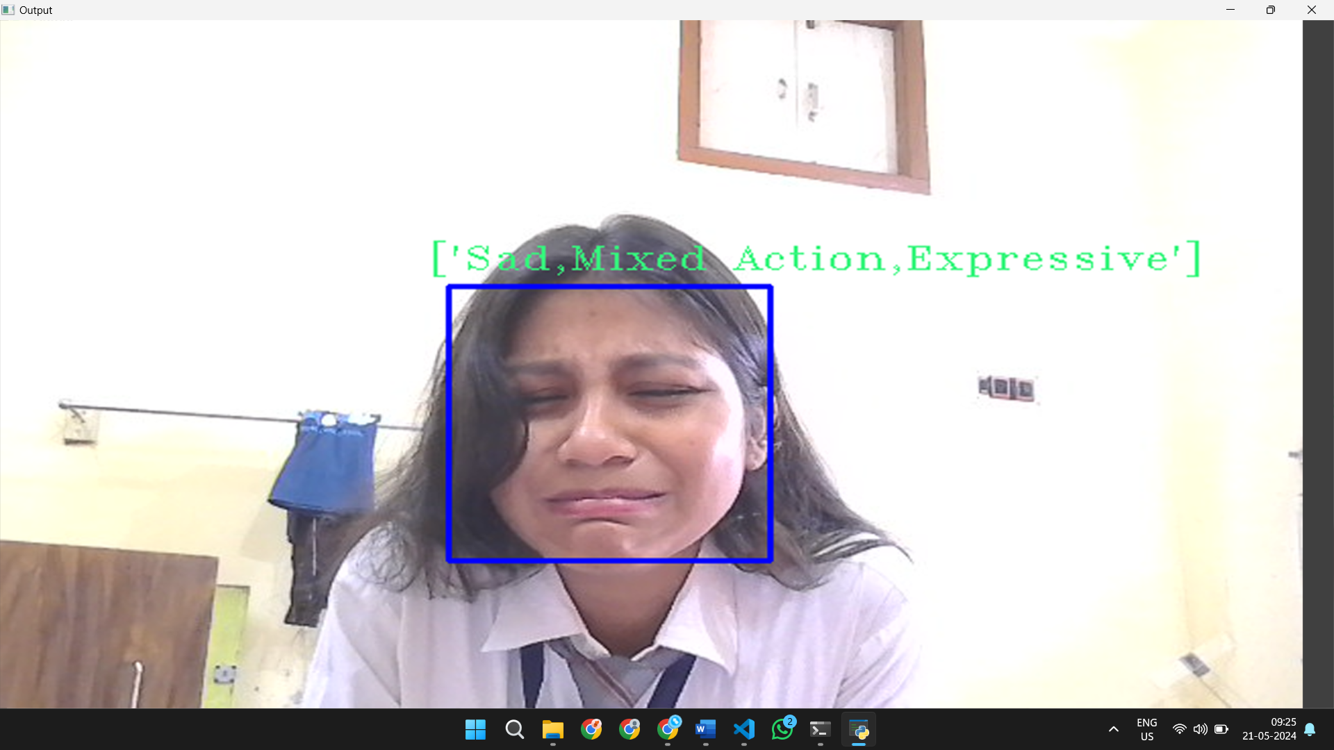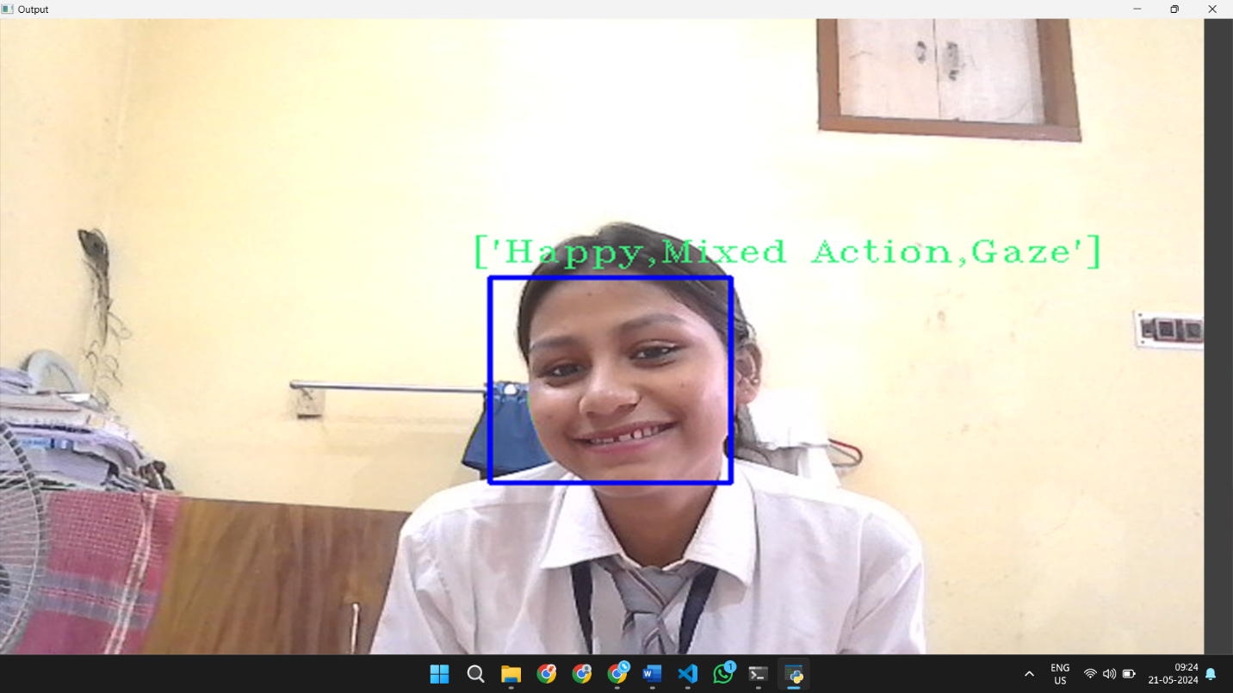

# **DISCUSSION**

The project “Real Time Emotion Detection with Manwatching” is a great start to deep dive into many use cases such as psychological well-being, retail and marketing and security and surveillance etc.

The application is limited to computer only to detect emotions and generate the output simultaneously. We can further deploy or embed this logic of the application into various use cases like security camera or phone camera to keep a track of long-term emotions and generate statistical data to identify clearly.

# **CONCLUSION**

Real-time emotion detection represents a significant advancement in the field of artificial intelligence with far-reaching implications for diverse domains such as human-computer interaction, mental health, marketing, and beyond.

Issues such as accuracy, bias, privacy concerns, and the integration of multiple modalities remain significant areas for improvement.

In conclusion, while there are challenges to overcome, the potential benefits of real-time emotion detection are vast. By continuing to innovate, collaborate, and prioritize ethical considerations, we can harness the power of these technologies to create more empathetic, inclusive, and human-centric systems that enrich lives and empower individuals in profound ways.

# **References**

1. *Cascade Classifier*. (n.d.). Retrieved from OpenCV: https://docs.opencv.org/3.4/db/d28/tutorial_cascade_classifier.html
2. Jaiswal, S., & Nandi, G. C. (2020). Robust Real-Time Emotion Detection System using CNN Architecture. *Neural Computing and Applications*, 11253-11262.
3. Jaymon, N., Nagdeote, S., Yadav, A., & Rodrigues, R. (2021). Real time emotion detection using deep learning. *2021 International conference on advances in electrical, computing, communication and sustainable technologies (ICAECT)*, 1-7.
4. Morris, D. (1977). *Man Watching: A Field Guide to Human Behaviour.*
5. Nguyen, B. T., Trinh, M. H., Phan, T. V., & Nguyen, H. D. (2017). An efficient real-time emotion detection using camera and facial landmarks. *2017 seventh international conference on information science and technology (ICIST)*, 251-255.
6. OHEIX, J. (2019). *Face Expression Recognition Dataset*. Retrieved from Kaggle: https://www.kaggle.com/datasets/jonathanoheix/face-expression-recognition-dataset
7. Pinto, G. (2022, June 22). *Emotion Detection in Python*. Retrieved from Medium: https://girolamopinto1.medium.com/emotion-detection-in-python-8642fade50a9
8. Puri, R., Gupta, A., Sikri, M., Tiwari, M., Pathak, N., & Goel, S. (2020). Emotion detection using image processing in python. *arXiv preprint arXiv:2012.00659*.
9. Saw, S. (2023, October 25). *Emotion Detection Using Convolutional Neural Networks (CNNs)*. Retrieved from GeeksforGeeks: https://www.geeksforgeeks.org/emotion-detection-using-convolutional-neural-networks-cnns/
10. Sun, Y., Sebe, N., Lew, M. S., & Gevers, T. (2004). Authentic emotion detection in real-time video. *Computer Vision in Human-Computer Interaction: ECCV 2004 Workshop on HCI, Prague, Czech Republic, May 16, 2004. Proceedings*, 94-104.